Do you have children between the age of 11-18 years?
Are you wanting to become more aware of online dangers, up to date apps, tips on how to parent a teenager, understanding their emotions & how their brain works? Then DICE is the perfect programme for you!

We can support and offer guidance for anyone who would like to know more about the risks of exploitation and how we can help to safeguard our young people.
The FREE DICE Programme is one area of our work and is a programme of support around the following –
About This Event
Session 01 – Introductions & talking about the life of a teenager
This session will cover; The Teenage Brain, Why teenagers might take risks & the pressures they are facing in the modern world.
Session 02 – The Exploitation of children & young people
This session will cover; Grooming – What it is? How does it happen? Where & by whom? How can we spot the sings? Active listening techniques, advice & guidance on these techniques, how we can approach conversations/situations, managing stress & pull factors.
Session 03 – Digital Dangers
This session will cover; Social Media, current apps & their ages/what they do/what to keep an eye on. Sexting, sending nude selfies & how we can be better digital parents/carers.
Session 04 – A space to share ideas about parenting
This session will cover; Parenting top tips, practical advice & information about the support available to all parents. Communicating effectivly with our young people, how life is parenting a teenager, support networks, working together, importance of reaching out & sharing information.
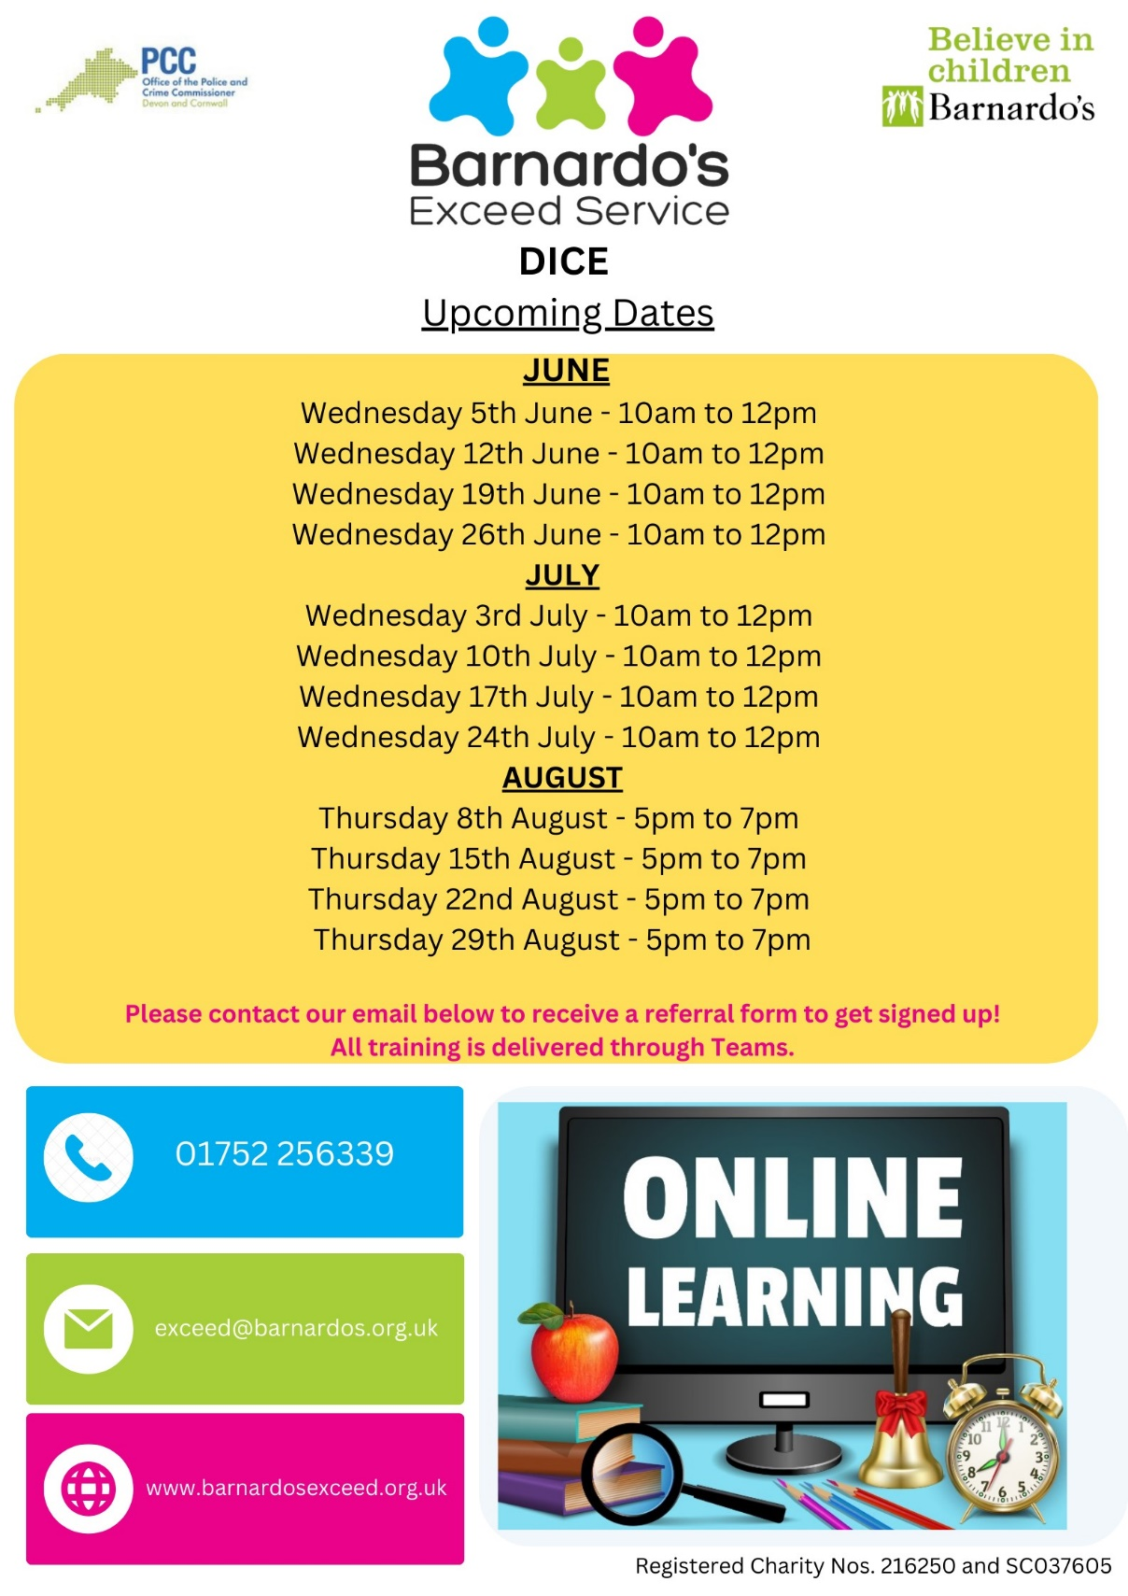


EventBrite Link - https://www.eventbrite.co.uk/e/910636316737?aff=oddtdtcreator
Google Form QR Code Eventbrite QR Code

