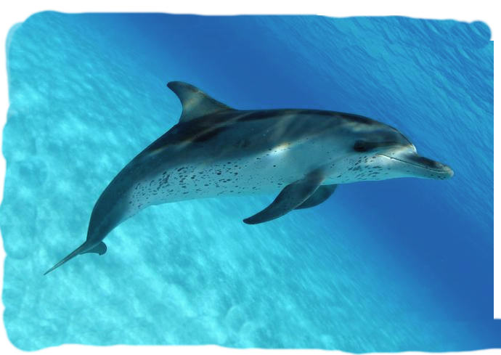

January 2016
Dear Parents and Carers

Happy New Year! I hope you all had a lovely Christmas.

Attached to this letter is an outline of the theme we will be covering and some of the activities planned for this term. We hope this will help you feel more ‘in the know’.

The children are moving swiftly on with their phonics learning and I would like to invite you to another Phonics Evening where I can talk to you about the next stage. The evening will be held on Tuesday 12th January at 6pm in the Dolphins room. I will also be holding parents meetings during the week of 18th January, please come and see me to arrange a time so that we can discuss your child’s progress.

Just a few reminders:
• Can children have a change of clothes in their bags please; as we do have the odd toilet mishap or water play or paint excitement and may need to change your child!
• Please can you ensure all children’s belongings are named; wellies, lunch boxes, water bottles, sweat shirts etc. We are working very hard to encourage children’s independence and this will help them to manage their own belongings.
• We ask that children say bye to parents in the cloakroom rather than the classroom, this is to reduce the number of adults in the classroom and help make the children independent.
• We currently have children within the setting who have severe food allergies so we ask that children do not have any nuts or nut products (e.g. peanut butter, Nutella) in their lunch boxes as even close contact with these ingredients can cause problems for children who are sensitive to these foods.
• I’m sure there have been many Wow! Moments celebrated over the holidays, we would love to hear about them. There are some attached to this letter and some more on the Parents’ Noticeboard.

If you have any concerns, worries or information you need to pass on about your child please come and speak to me.

Thank you for your continued support.
Claire Bannister

