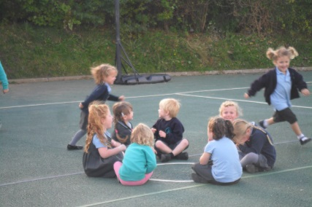
British Values in The Early Years.
British Values is taught through the Personal, Social, Emotional Development and Understanding of the World strands of our curriculum.
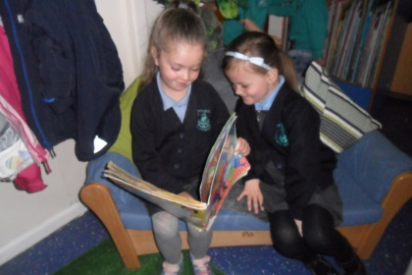
From the first day of each academic year, our children are involved in devising our ‘Golden Rules’ which are displayed and followed throughout the year. The children will often remark when them or another child is displaying/following one of our rules. The children are also involved in the planning of our topic each term, following their interests and going with the needs of the children. After the film ‘Frozen’ was released we just had to do a topic around this as this was all the children were singing! This term we have had many children interested in woodlouse so we decided to have a mini topic on mini beasts, centred around the story ‘The Very Hungry Caterpillar.’ The children are also involved in changing and setting up our role play areas, the staff listen to what they want in there and help resource it.
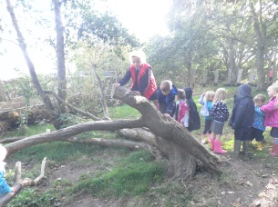
As part of our ‘Golden Rules’ and the PSED curriculum, children are encouraged to take turns and share and to know the difference between right and wrong and activities are planned to help support the children take these important social skills into their independent learning time. Our routines are developed throughout the Unit so that the children feel happy and comfortable and ready to learn. Once this is established, adults in the setting can support the children in developing their self-esteem and confidence and encourage them to have a go and to take risks through well planned activities both inside and outside. This often results in children knowing when they do or do not need help, asking for it as and when they need it and children keen to show off their learning to their peers and adults.
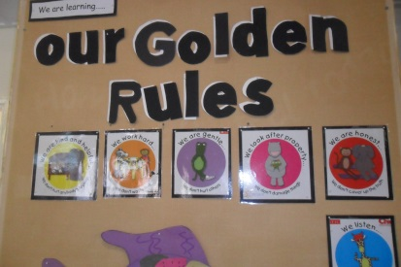
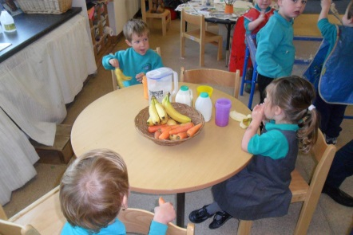
Appledore Foundation Unit is part of the community, walking into the village half termly to visit the local library and the lifeboat station during the summer term. We also celebrate other faiths during October (Divali) and February (Chinese New Year.)
