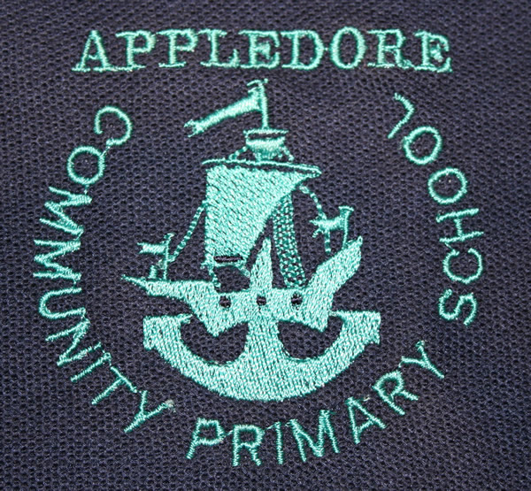
APPLEDORE COMMUNITY PRIMARY SCHOOL & NURSERY

Fair Processing Notice Layer 1

Appledore Community Primary School & Nursery processes personal data about its pupils and is a “data controller” in respect of this for the purposes of the Data Protection Act 1998. It processes this data to:
- support its pupils’ teaching and learning;
- monitor and report on their progress;
- provide appropriate pastoral care, and
- assess how well the school as a whole is doing.

This data includes contact details, national curriculum assessment results, attendance information, characteristics such as ethnic group, special educational needs and any relevant medical information.

This data may only be used or passed on for specific purposes allowed by law. From time to time the school is required to pass on some of this data to local authorities, the Department for Children, Schools and Families (DCSF), and to agencies that are prescribed by law, such as the Qualifications and Curriculum Authority (QCA), the Office for Standards in Education (Ofsted), the Learning and Skills Council (LSC), the Department of Health (DH) and Primary Care Trusts (PCT). All these are data controllers in respect of the data they receive, and are subject to the same legal constraints in how they deal with the data.

The Fair Processing Notice has been prepared at a time of change with the restructuring of the Department for Education and Skills and the Department of Trade and Industry into three new Departments: the Department for Children, Schools and Families (DCSF), the Department for Innovation, Universities and Skills (DIUS) and the Department for Business, Enterprise and Regulator Reform (DBERR). It may be that, [during the period covered by this FPN], steps will be taken to enable the DCSF to match individual pupil information with higher and further education attainment data held by the DIUS.

Pupils, as data subjects, have certain rights under the Data Protection Act, including a general right to be given access to personal data held about them by any data controller. The presumption is that by the age of 12 a child has sufficient maturity to understand their rights and to make an access request themselves if they wish. A parent would normally be expected to make a request on a child’s behalf if the child is younger.

If you wish to access your personal data, or that of your child, then please contact the relevant organisation in writing. Details of these organisations can be found on the following website www.devon.gov.uk/eal/dgfl/fairprocessing or for those pupils/parents where this is not practical, a hard copy can be obtained from the School. Please contact Mrs Bettis in the School Office.

Your attention is drawn to Layer 2 of this Fair Processing Notice, which gives supplementary information about the processing of pupil data by the organisations mentioned above, and to the Full Notice Layer 3 which gives greater details of how the pupil data is processed and the rights of parents and pupils. Either can be obtained from the Parent’s Pages of the School Website
(www.appledore-primary.devon.sch.uk) or an inspection copy is available from the Office.

Headteacher: Mr Jeremy Cooper

