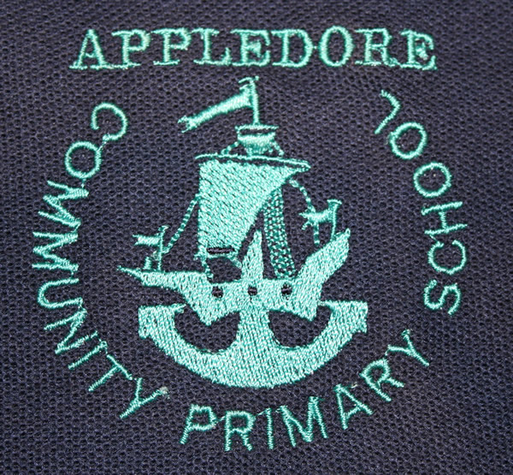

APPLEDORE COMMUNITY PRIMARY AND NURSERY SCHOOL

COLLECTIVE WORSHIP

Reviewed/agreed by staff
Reviewed/agreed by Governors
Initials

Introduction

At Appledore Community primary and Nursery School we believe that Collective Worship plays a very important role in the life of our school. It is an opportunity to celebrate all aspects of school life to support our curriculum and to provide an opportunity for stillness and reflection in what is often a very busy, active day for our children.

Aims

The central aims of Collective Worship at Appledore Community primary & Nursery School are to:

- provide our children with regular opportunities for stillness and reflection
- promote children’s spiritual, moral, social and cultural development
- celebrate the values and worth of the school community and all who belong in it, including the sharing of the gifts and talents of our children.
- help children develop and understanding both of the nature and language of worship
- help children develop respect and sensitivity to the beliefs and values of others
- support the broader curriculum through the use of art, music, dance, story, drama and other visual and oral means of communication.

The Legal Position

The 1988 Education Reform Act states that collective worship must be on a daily basis for all registered pupils. Furthermore, acts of worship “must be wholly or mainly of a broadly christian character, i.e. reflect the broad traditions of Christian belief.” At Appledore we have developed a range of themes and topics through which collective worship takes place. Key themes include love, joy, trust, forgiveness, justice and the value of all human life. We believe these themes are clearly Christian in nature but are universal in their application. We recognise that in our school we have children from a variety of faith backgrounds and that many children have no religious background at all. Great care is taken in our collective worship to ensure that all children feel valued and special and that their integrity as human beings is consistently upheld. Collective Worship at Appledore is an inclusive activity. Parents do have, of course, the right of withdrawal from Collective Worship. Parents who have any concerns about the provision and practice of our Collective Worship are strongly encouraged to contact the Headteacher.

Context of Collective worship

In order to promote children’s learning, our acts of worship vary in size. Our pattern is set out below:

Monday - KS1 & 2 assembly (special theme related to culture/festivals and celebrations)
Tuesday - SEAL based Key Stage assembly
Wednesday - Key Stage/Class-based assembly
Thursday - Open the Book assembly (KS1 & 2 plus F2 as appropriate)
Friday - KS1 & 2 assembly (plus F2 as appropriate) (celebration of achievement)

Visitors play an important part in the life of our school and regularly contribute to acts of worship. We record our acts of worship to inform our learning and plan for further developments. We are developing a range of resources to enhance children’s learning. These include stories, music, slides, poems, pictures and posters and dvds all of which we hope contribute to a stimulating and thoughtful time for our children.

Conclusion

Collective Worship plays a very important role in our school as we seek to develop our children in the skills of reflection and empathy, to encourage and celebrate their talents and to promote their spiritual and moral development.

